Marketing Website
Duties
NKC Banner
- Add [adrotate banner="46"] aan onder kant van NKC artikel
NKC Artikels
- Laai Artikel, Banner sal automaties daar wees
- Maandag: Stuur mail link na paul
Market Commentary: Nigeria - Real GDP growth rises in Q3
Nigeria’s real GDP growth improved in the third quarter on the back of higher oil production as well as an increase in non-oil GDP growth. Real GDP at factor cost expanded by 6.81% y-o-y in the third quarter of 2013, up from 6.18% y-o-y in Q2 and 6.56% y-o-y in Q1. Read more

Link: http://www.moonstone.co.za/?p=11913

Job listing – Careers platform
- 2 Options
- Featured option (ad appears on website & e-newsletter)
- Website option ( ad appears on website)
- At joblisting, on dashboard, review ad for mistakes (Listing will display under “Pending Payment” tab)
- Change the “author” to the clients name, update their profile picture and add “about us” of the company. (This will fall under “users” not job listings)
- Send email to client, saying that you received the submission and the ad will be active once payment is received.
- Wait for payment to be made (follow up when payment is not received in time period)
- Activate ad
Careers platform ad in Monitor en II
- Public/Marketing/Website/Career Platform/Newsletter Copy
- Open previous document
- Check if all jobs listed is active
- Change footer to ms-dk/date?
- Send document to anton van rooyen every Monday/Thursday mornings

MS Documents – Upload on website:
- Save Document as PDF in Website uploads – public drive: marketing/webstite/website uploads/ RE
- Login Moonstone website CMS: www.moonstone.co.za/wp-admin
- At Moonstone Dashboard
- Select: WPS Filebase Pro
- Select: Files
- Browse for file in Uploads folder
- Select relevant Category for the file
- Add file
- Send link to whoever wanted the file to be uploaded.

MS Blog– Upload on website
- ‘Add new post’ (top left hand corner on moonstone dashboard wordpress)
- Copy and paste Pauls writings from the Word document
- Title it
- Categorize it – Pauls Perspective
- Paul's Perspective
  - Cricket
  - SA Rugby
  - SA Sport
  - Sport general
  - Sport Spot
  - Super 15
  - World Cup Rugby
- Add Tags

Tags
Add or remove tags
Tags

- Add picture by Googling most recent picture of Pauls request. Save picture in pictures/website pictures.
- Add it next to related section by 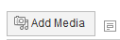
- Add photo as a ‘thumbnail’ and describe the pic as the individual name.
- Add Featured image by clicking on tab and selecting ‘Upload Files / Media Library’

Featured Image
Set featured image
- Preview the blog and if ok, ‘publish’
- Obtain link by selecting ‘ get short link’ and send to Anton Van Rooyen
- Add link to MS facebook page
http://www.facebook.com/#!/pages/Moonstone-Information-Refinery-Pty-Ltd/267440846622609

Newsletter Articles to upload to website
- To be uploaded on same day as release(Mondays, II and Thursdays, Monitor)
- In dasboard select New Post
- 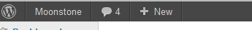
- Copy and Pauls Article into post, enter title above too
- Categorize the article ( depending on the particular topic)
- Make sure text all same size/format/colour
- ‘Preview’ the article before pressing ‘publish’
- Things to remember:
  - Change “Author”
  - Set Display Image (Size 610x220) (Use modern pictures, not the old MS Word Graphics)
  - Add Tags relevant to article
Social Media
- Try to post all articles on all social media platforms throughout the week. (Twitter, Linkedin, Twitter automatically posts on facebook as well)
- Join LinkedIn groups on which you can post articles that Paul writes

Queries received via website
- Licensing - Abigail Sampson ASampson@moonstoneinfo.com
- Training / long term / short term FAIS accrdiatation etc - Ronel Nell ronel@moonstoneinfo.com
- Examiniations – Fais Exam
- Newsletters – don’t forward as Anton v Rooyen receieved these
- Marketing ( eg, workshops/study material/DVD/courses/ ) – us
Moonstone people
- Make sure Moonstone collegues are always updated with their profile pic on the ‘my contact page’ on the website – contact Schalk with updated picture information and stipulate the department in which they work in.

Events Page (when setting up a Workshop eg.)
- When creating an event (workshop) call upon Schalk
- Make sure you have all details
    - Event Name
    - Venue and address
    - Start and end date of registration
    - Start and end time of event
    - The presenters
    - What you will be charging each induvidual ( excl VAT)
    - Attendees limit
    - Refer to ‘Workshops’ folder in Public/Marketing for examples on how the invite looks
- To manage events:
    - Wordpress / MS Events / Event overview and click on the specific event
    - There are various actions on the right hand side, which can be chosen from in order to control ( View/ edit/ delete/ attendees and Export to an excel speradsheet)
    - 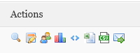
- To manage payment:
    - Proof of Payment is asked for as the client books and pays
    - Client receives an invoice upon booking via our events page on the web
    - POP is sent to the email address stipulated through an email as an attachment along with the booking and invoice form
    - Once received, go back into the event and click on the induvidual.
    - Go to payment options and after checking the person paid the correct amount into the correct bank account, change his payment status to ‘Complete’
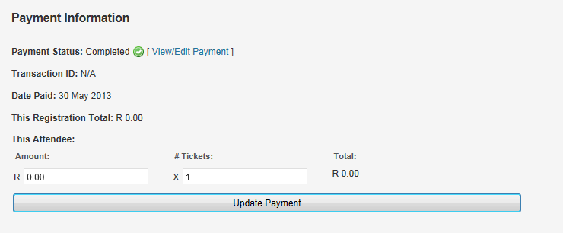
    - Reconcile towards the end of the registration date with Marna in finance
    - She will print out a list showing all persons who have paid the specific amounts
    - Go into each person within the event and click on complete.
    - Contact those induviduals who have not paid 2 days prior to event.

Updating exam schedules
- Apon recieving update from Filansia – check and get confirmation from Ilsa Lotter first
- If correct, save doc in Website uploads, RE updates
- Then go to Moonstone Dashboard
- MS Filebase
- Files
- ‘Search’ ‘Moonstone Examination Dates - 2014’ in the search tab or for Afrikaans ‘ AFRIKAANSE EKSAMEN’
- Replace file by clicking on the ‘Browse’ tab
- Remember to always press ‘ Update’ at the bottom!
- Go to Pages and select “Regulatory Exam” page.
- Update hyperlink with new link to the updated file

Mail Chimp

- Use this mail system, before, during and after the event
- Before – is used to get the attention and detect approx. interest of attendees per event.
- Steps:

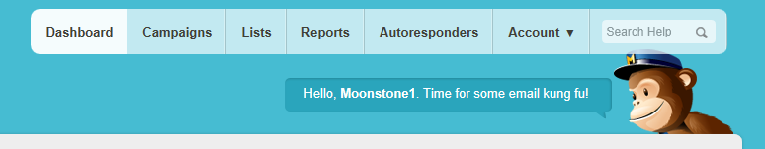
    - Campaigns – you can either build a new campaign or replicate one my choosing’ My Templates’ depending on the function you want to perform
    - Or replicate straight from campaign
    - Refer to my templates and previous campaigns done in the past.
    - Create a list by adding email addresses (export via excel ) is the easiest
    - Always send a ‘test’ to your email address before sending it out

Survey Monkey (when wanting feedback or conducting a random survey)

- Use the templates that have been conducted in the past:
- Go into ‘Create Survey’
- Either create and new one / or copy an exsisting one ( depending on your function)
- 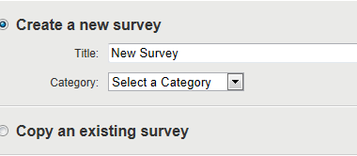
- Title and categorize the survey
- Discuss new questions with bobby and once decided then create new survey
- If using existing one, make sure all questions are relevant otherwise ‘edit’ each question.
- Always send a test survey, and always Preview the survey before sending it out
- After designing and sending out survey – monitor it / collect repsponses and analyse results
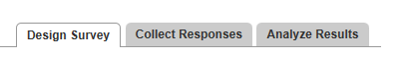

Creating Monthly Report

Login to http://www.google.com/analytics/index.html
Username: pkruger@moonstoneinfo.com
Password: moonstoneinfo
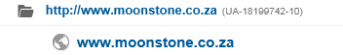
All previous reports are saved in Public/ Marketing / Management reports / 2014
The excel stats are saved in the Data graphs.xlsx
Follow the Index steps and work through these on new month ( copy and paste from previous months)
INDEX:
1: Website
a. Absolute Unique Visitors (AUV)
b. Traffic Sources
c. ‘Contact Us’ webpage stats
2: Campaigns / Events / Brochures
3: Blog
4: Social Media
5: Newsletters
6: DVD’s
TO START:
Choose your month and press apply:
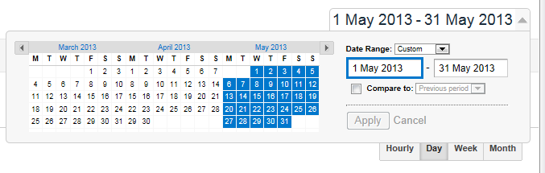
A: Find Unique visitors and place amount in the excel spread sheet – ‘ Visits for Website’

b. Traffic Sources are also done by clicking on Traffic sources / overview and then refer to the pie chart which is displayed
- Complete information on the Traffic Sources excel sheet then copy and paste chart into the Full REPORT
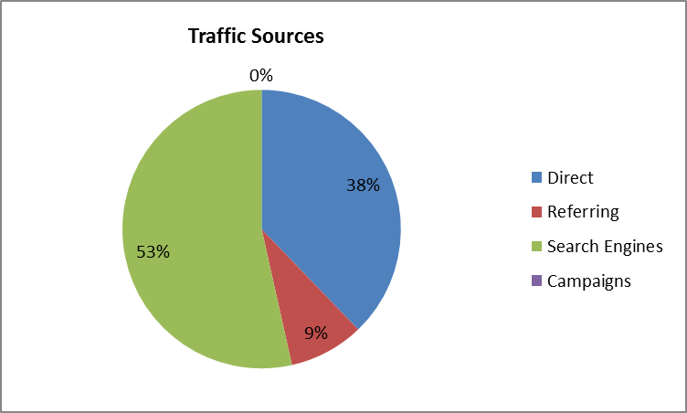
- Also record top referrals and keywords which is displayed
The 1c: Moonstone ‘’Contact us’’ Webpage statistics – is done via the MS Dashbord
- Select MS Design then select a form - Choose contact Page – Sept 2012
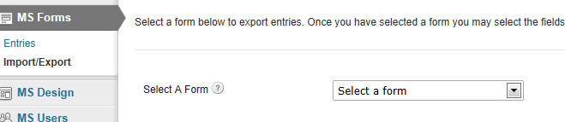

- Select ‘Please select the relevant department’
- Capture correct date range( start and End)
- ‘ Download Export File’
- Export and sort colum A by selecing A-Z
- Count each relevant department and capture in Excel spread sheet in Marketing/ Management reports and Stats ( ‘ Contact us’ graph)
- Copy and paste graph in month ‘Full Report’
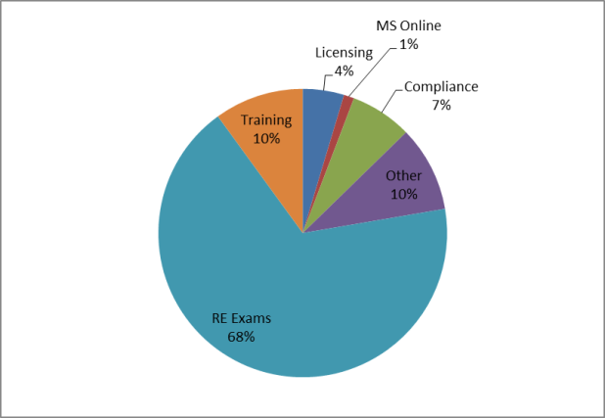
3: Moonstone Blog: ‘Pauls se Perspektief ‘

- Is done via Dashboard
- Select ‘ all posts’ on left hand side
- Use the Show all dates and choose month. Then Filter by selecting Pauls Perspektief
- Capture names of blog entries
- Then go to google analytics
- Content / Site Content / Overiview and All pages
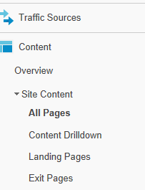

- Capture Unique Page views per entry
- Calculate Ave Monthly Blog visits by dividing the total visits by the number of entries
- Capture this on the BLOG ENTRIESExcel Stats sheet and copy into the full report
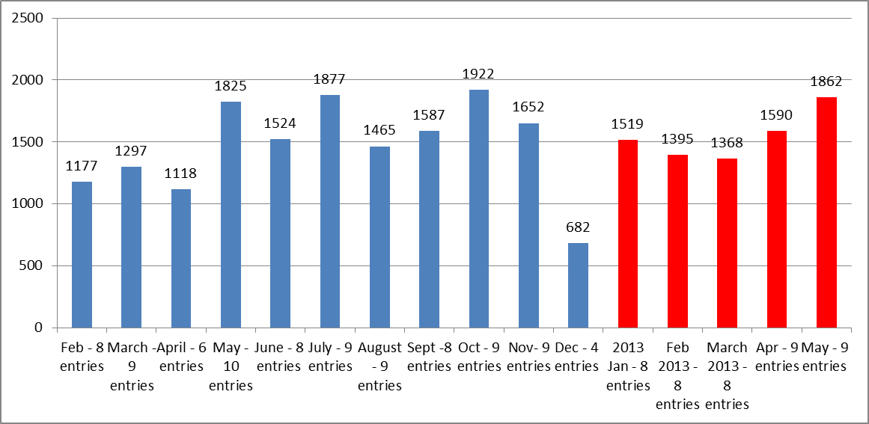
4: Moonstone Social Media -
- Captured by login into each media account – stats are shown on webpage
5a: Moonstone Newsletters
- Request form Anton – at end month
5b: Newsletter Advertisements
- Media Marx Stats are sent by Michelle
- Total earning for newsletter stats are received by Tracy van Heerden on a monthly basis
6: Moonstone DVD Orders
- Received by Tracy van Heerden on monthly basis
- Capture on excel spread sheet and copy new graph into Full report

NB Make a summary report by taking the details from FULL report.
May - M & C - Summary Report
Points and stats to capture on Summary:
1: Website
2: Blog
3: Social Media
4: Newsletters
5: DVD’s

